

Mohd. Razia Alangir Banu
MALLAVARPU BALA PRANITHA
2520030051
CSE
CO-4

Case study topic : MediFlow – Hospital Patient Prioritization & Resource Optimization

Workdone summary: The MediFlow system was developed to manage patient records and optimize hospital resources. Quick Sort and Heap Sort were used to rank patients based on priority and severity. Counting Sort and Radix Sort were applied to sort large patient ID datasets efficiently. Greedy algorithms were used to allocate doctors and beds to maximize patient treatment. Dynamic Programming techniques were implemented to select optimal treatment plans while minimizing cost and resource usage.

Implementation Details:
- Quick Sort is used for fast patient ranking based on severity scores.
- Heap Sort is used to maintain priority queues for emergency patients.
- Counting Sort sorts patient IDs when the ID range is limited.
- Radix Sort processes large numerical patient IDs efficiently.
- Greedy algorithms allocate doctors and beds to maximize hospital utilization.
- Dynamic Programming is used to determine optimal treatment plans under resource constraints.

Result:
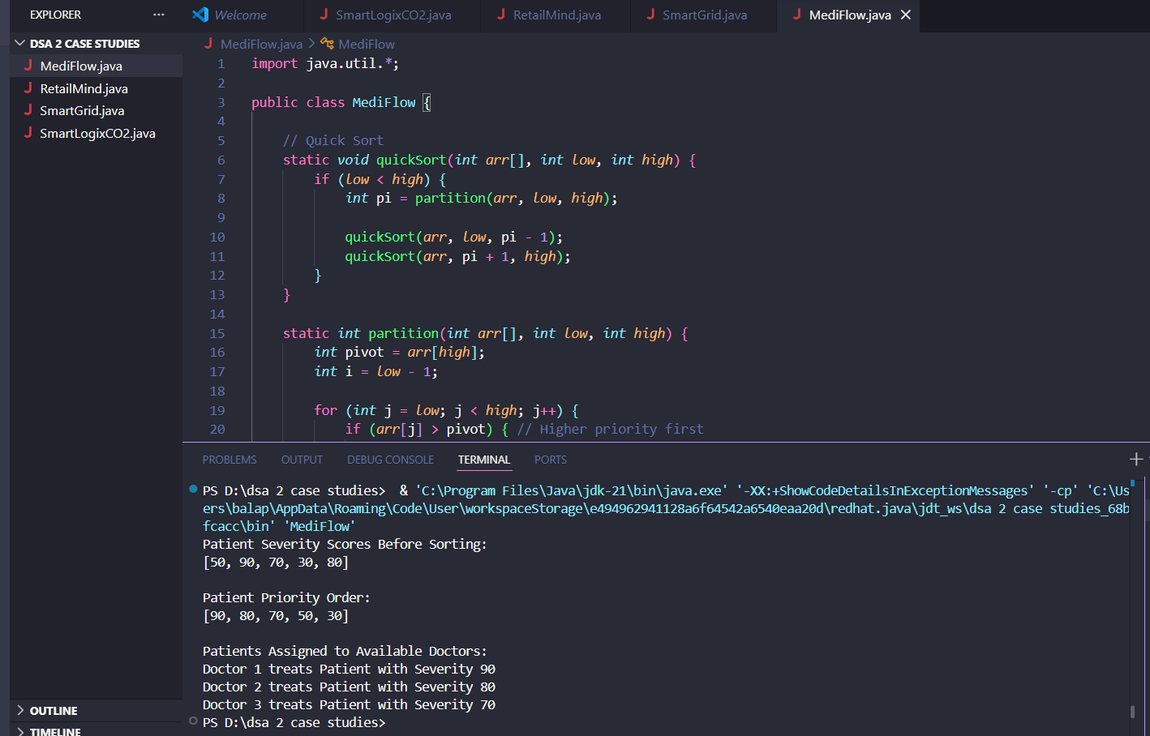

MediFlow uses Quick Sort to prioritize patients based on severity and a Greedy approach to allocate available doctors to the most critical patients first. This improves treatment efficiency and ensures optimal utilization of hospital resources.

Github Link: https://github.com/balapranithamallavarapu-cmyk/DSA-II-Case-Studies

